Day 33 – 13th September – 113195064 – Bondili Bhavya Charitha
Task:1 – Creation of Cluster is done (Yesterday’s class)
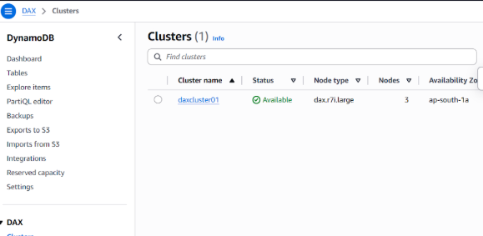

Task:2 –
package org.example.Accelerator_DAX;
import software.amazon.awssdk.auth.credentials.DefaultCredentialsProvider;
import software.amazon.awssdk.auth.credentials.DefaultCredentialsProvider;
import software.amazon.awssdk.regions.Region;
import software.amazon.awssdk.services.dax.DaxClient;
import software.amazon.awssdk.services.dynamodb.model.AttributeValue;
import software.amazon.awssdk.services.dynamodb.model.GetItemRequest;
import software.amazon.awssdk.services.dynamodb.model.GetItemResponse;
import software.amazon.awssdk.services.dynamodb.model.PutItemRequest;
import java.net.URI;
import java.util.HashMap;
import java.util.Map;

public class AcceeleratorDAXDemo {
public static void main(String[] args) {
//get this end point created using AWS cloud
// create a acluster..
String daxEndpoint = "daxs://daxcluster01.ee3lf0.dax-clusters.ap-south-1.amazonaws.com";

// we are creating DAX client
DaxClient daxClient = DaxClient.builder()
.endpointOverride(URI.create(daxEndpoint))
.region(Region.AP_SOUTH_1)
.credentialsProvider(DefaultCredentialsProvider.create())
.build();
String tableName = "Employees01";
String KeyName = "ID";
String KeyValue = "10001";

Map<String, AttributeValue> item = new HashMap<>();
item.put(KeyName, AttributeValue.builder().s(KeyValue).build());
item.put("msg", AttributeValue.builder().s("we are creating DAX ").build());
PutItemRequest request = PutItemRequest.builder()
.tableName(tableName)
.item(item)
.build();

daxClient.putItem(request);
Map<String, AttributeValue> getItem = new HashMap<>();
getItem.put(KeyName, AttributeValue.builder().build());
GetItemRequest request = GetItemRequest.builder()
.tableName(tableName)
.key(getItem)
.build();
GetItemResponse response = daxClient.getItem(request);
System.out.println("Dax working ..");
daxClient.close();
}
}
<dependency>
<groupId>software.amazon.awssdk</groupId>
<artifactId>dax</artifactId>
<version>2.20.100</version> <!-- Use the latest stable version of the SDK -->
</dependency>

Task: 3 – Holded by mehar – said she has to still work on it to give code.

Task:4 –
package org.example;
import lombok.Data;
import java.sql.Struct;
import java.util.List;

@Data
@DynamoDBTable(tableName="Students")
class Students {
@DynamoDBHashKay(attributeName="ID")
private String ID;

@DynamoDBAttribute(attributeName="SName")
private String Name;
}
//DynamoDB Access
class DynamoDBAccess {
private DynamoDBMapper Mapper = new DynamoDBMapper((AmazonDynamoDB) AmazonDynamoDBClientBuilder.standard().build());
public Students getItem(Students item) {
return Mapper.load(Students.class, item.getID());
}
public void saveItem(Students item) {
Mapper.save(Item);
}
public List<Students> getItems(Students item) {
return Mapper.query(Students.class, new DynamoDBQueryExpression().withHashKeyValues(item));
}
}
public class DynamoDBMapperClass {

public static void main(String[] args) {
}
}
Lombok dependency
<dependency>
<groupId>org.projectlombok</groupId>
<artifactId>lombok</artifactId>
<version>1.18.20</version>
<scope>provided</scope>
</dependency>

